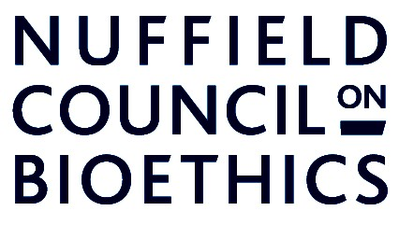

Conducting research and innovation in the context of global health emergencies: what are the ethical challenges?

Friday 9 December 2016
28 Bedford Square, London WC1B 3JS

10:00
Introduction from the Chair, Jonathan Montgomery

10:05-10:45
Tensions between response (to emergencies of various kinds) and research

- How do humanitarian response and diverse forms of research/innovation fit together?
- Access to innovative therapies – questions of participant selection/ fair access where research interventions represent only hope of treatment?
- Tensions between research and care ethics - scope for a new ethics of ‘research as response’?

10:45-11.30
Research conduct and governance in GHEs: specific challenges

- Involvement of local communities – whose voices are heard and where does the power lie?
- Standards of evidence/ governance/ ethical review – justification for different approaches in emergencies?
- Adaptive trial designs
- Role/ limitations of anticipatory scrutiny

11:30-12:00: COFFEE BREAK

12:00-12:45
Setting priorities and challenges of collaboration

- Who makes decisions, how and where? - setting research priorities from global to local level
- Responsibilities of funders (public/private/charitable) with respect to wider impacts of funding choices and sustainability
- Collaboration and oversight – ethical responsibilities on those with power to cooperate?

12:45-13.30
Are there ‘ethical gaps’ and who should plug them?

- Open discussion

13:30 LUNCH

