**NCOB logo (med res).jpg**

**Bioethanol from corn in the USA**

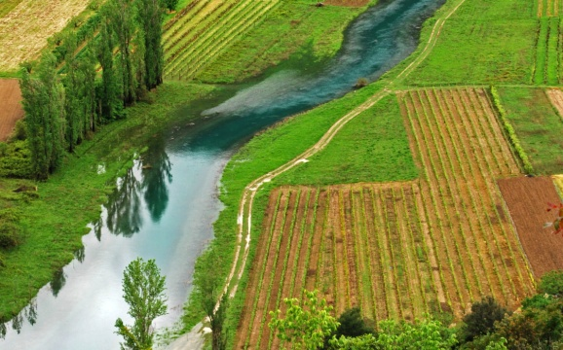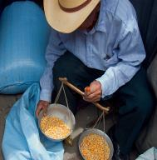NCOB logo (med res).jpg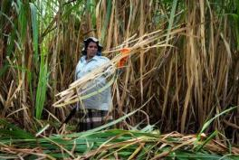**Bioethanol from sugar cane in Brazil**

**Use of Water**

A study has estimated that the amount of water used by a corn ethanol plant is much more than is used in refining petrol. It uses about 4 gallons of water for every gallon of ethanol produced compared to 1.5 gallons of water for every gallon of petrol produced.

**Greenhouse gases**

The production of bioethanol from corn involves several stages of work including soil cultivation, fertiliser use, irrigation, harvesting, transporting the corn, extraction of sugars to make the biofuels from, processing, refining and transporting the finished biofuel. There is some controversy over whether bioethanol from corn reduces overall greenhouse gas emissions if you take into account all of these different steps.

The incentive for bioethanol production has become more compelling as the price of oil has continued to rise.

**Water quality**

Fertiliser is used to help the corn grow. When it rains the rainwater mixes with the fertiliser to create fertiliser run-off. The run-off flows down to rivers and streams and causes nutrient pollution. Rivers such as the Mississippi River system could become more polluted as a result of corn bioethanol production. This sort of pollution has already helped to cause the ‘dead zone’ in the Gulf of Mexico where many forms of sea life cannot live because there isn’t enough oxygen in the water.

**Increase in food prices**

The production of corn bioethanol in the US was blamed for causing increases in the price of corn and other grains. The ‘tortilla riots’ in Mexico during late 2006 and early 2007, are one example. Tortilla is a staple food in Mexico, made from corn. With the high demand for corn to make bioethanol, the price of corn soared dramatically high. Street demonstrations took place with thousands involved in the marching. The Mexican Government eventually had to intervene to keep the prices down.

The USA is the world’s largest bioethanol producer. Being able to produce bioethanol from corn means that the USA has an alternative method of producing fuel if oil begins to run out or oil prices suddenly increase. However, the industry has been partially blamed for increasing the price of corn and other grains in developing countries. There are also disputes over whether corn-based ethanol produces fewer overall greenhouse gas emissions than fossil fuels.

**Wages**

Wages for cutters are now higher than the Brazilian minimum wage, but may still not be enough to avoid poverty. Cutters may also have to pay excessive fees for food, housing or return transport when they move to a sugar cane estate.

**Water use**

Sugar cane production uses a lot of water (up to 4 litres of water per litre of ethanol produced). There are also concerns about rivers being contaminated by the fertilisers that the famers use on their crops.

The Brazilian Government began to promote bioethanol as a transport fuel in response to the energy crisis of the 1970s.

Brazil has the highest uptake rate of bioethanol in the world, and it is the largest exporter of ethanol fuel. Brazilian ethanol production is hailed by some as the most successful example of a large-scale biofuels programme. By others it has been criticised for contributing to deforestation in rich habitat areas, leading to a loss of biodiversity. Many are also concerned about abuses to worker’s rights including unhealthy working conditions and informal child labour.

**Deforestation**

Some people are worried that some forests will be cut down and cleared to make way for the fields of sugar cane. These are areas of high biodiversity, and an expansion of agricultural production may destroy these rich habitats and their associated biodiversity.

**Workers rights**

There have been reports of contemporary slavery among sugar cane cutters in Brazil. For example, in 2007, Amnesty International highlighted the rescue of more than 2,000 workers from forced labour conditions.

Sugar cane cutting is extremely demanding. Sugar cane cutters are estimated to strike a machete up to 12,000 times a day. Many of these workers use anti-inflammatory drugs and painkillers on a regular basis. An investigation into the death of a cane cutter found that he had worked a shift lasting 70 uninterrupted days. There is also informal child labour and it is estimated that 3% of all employees are child workers.

**Benefits for the local community**

On the other hand, the ethanol production sector supports schools, day care and nursery centres. More than 80% of production facilities provide some health and pharmaceutical care, transportation, collective life insurance and meals.

**NCOB logo (med res).jpgBiodiesel from palm oil in Malaysia**

Source: http://www.bbc.co.uk/news/business-13941458

Malaysia has a national policy to promote renewable energy, for a number of reasons: to develop sources of energy that are environmentally friendly; to reduce the dependency on fossil fuels and to develop agriculture and a business that can boost the economy. It is the second largest international producer of palm oil (after Indonesia). The conversion of forests to palm oil biodiesel plantations has raised concerns over detrimental impacts on biodiversity in the region. There are also concerns that ‘land-grabs’ by palm oil producers looking to obtain land for growing biofuels crops may be forcing out indigenous communities.

Malaysia’s biofuels industry helps develop agriculture in the region and provides a boost to the economy.

**Effects on wildlife**

When forests are converted to palm oil plantations this can contribute to the loss of habitats of many species such as forest birds and butterflies. Rare species such as the orang-utan of Borneo are at risk of extinction through loss of habitat in some areas. What’s more, orang-utans might also be at risk of being hunted by plantation managers looking to protect their crops from damage.

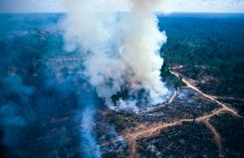

**Land rights**

There have been accusations of ‘land grabbing’ by biofuel companies. In an investigation into palm oil production in Sarawak, Borneo, a member of an indigenous tribe there reported, “*They just simply come and bulldoze our farm and our coco trees…They never come to us, to talk to us about this. We tried to negotiate with them but what they say to us [is] they have more right than us here*.”

In reply many of the companies deny the accusations. They say that they have never forced any natives from their lands. In fact they say that some tribes accepted payments and willingly handed over their land.

**Greenhouse gases**

In the long term, producing biodiesel from palm oil could reduce greenhouse gas emissions. However, in the short term they could actually cause more. When tropical forest land is converted to palm oil plantations, many trees are lost, meaning there are less trees to absorb carbon dioxide from the atmosphere. According to one report, it would take 86 years before the greenhouse emissions produced by biodiesel from palm oil became less than those produced using petrol.

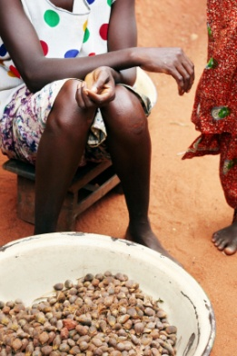

**Food security**

Palm oil has always been used in foods and cosmetics. Since it has started being used for biodiesel, palm oil is much more in demand. This means that the price of palm oil and other vegetable oils has increased. There is a concern that other foods that use palm oil, such as bread and chocolate, have also increased in price.

**NCOB logo (med res).jpgBiogas from pig poo in the UK**

Source: http://www.bbc.co.uk/news/business-13941458

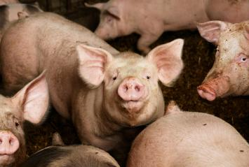

Source: http://www.bbc.co.uk/news/business-13941458

**How many biogas refineries are there in the UK?**

The UK does not have many biogas refineries just yet but there may be more in the future.

Other countries, for example, Germany, have many biogas refineries.

**Greenhouse gases**

Methane is one of the worst greenhouse gases — about 20 times worse than carbon dioxide in trapping heat in the atmosphere. The process of making biogas captures the methane produced by the waste.

**Weather dependent**

Because it is a naturally occurring process, the rate of biogas production is not easy to control and it can only produce a limited amount of energy. For example, production slows down in cool weather.

**Profit**

One farmer in the UK who recently set up a biogas refinery on his farm is expecting to produce around 2.2 million kilowatts of electricity each year. This is enough to power more than 175 homes. He could sell it for around £300,000. What’s more he could save £30,000 in fuel bills for the farm.

Pig farming is not as profitable as it once was, and farmers are looking at ways to find another source of income and improve the environmental impacts of their farms.

**How does it work?**

Pig manure is loaded into a large container where it is gradually broken down, by naturally occurring bacteria, in a process called anaerobic digestion (digestion in the absence of oxygen). This process produces methane, which is siphoned off, cleaned and filtered. This gas can then be burnt to release energy for heating and electricity. Alternatively, the gas can be compressed into a liquid and used for transport fuel. A by-product of the process is fertiliser.

Farming pigs leaves farmers with a problem; what to do with the tonnes of pig poo they produce? Biogas is a mixture of methane and carbon dioxide gases which can be produced from many sources of waste, including pig poo.

**Debt**

Some reports claim that communities in Borneo who decide to become part of the Oil palm expansion find themselves worse off in the end. This is because they end up in debt to the big palm companies. The people borrow money at high interest rates from the oil palm company for seeds and other agricultural supplies. However, the plots of land take seven years to produce fruit, and during this time more agricultural resources are required, which are purchased from the company. When the land becomes productive, the level of income is low so these small holders, with the large start-up costs, can end up perpetually indebted.

**Debt**

Some reports claim that communities in Borneo who decide to become part of the Oil palm expansion find themselves worse off in the end. This is because they end up in debt to the big palm companies. The people borrow money at high interest rates from the oil palm company for seeds and other agricultural supplies. However, the plots of land take seven years to produce fruit, and during this time more agricultural resources are required, which are purchased from the company. When the land becomes productive, the level of income is low so these small holders, with the large start-up costs, can end up perpetually indebted.